Big Mountain is currently the most expensive resort in Montana so is already perceived as a high-end resort. Modeling scenarios support ticket increases to generate more revenue and offset the cost introduced with the new ski lift.

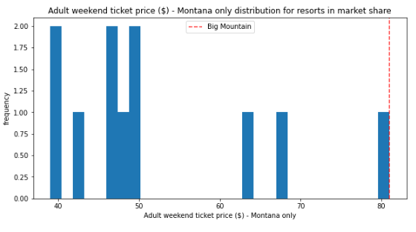

**Assuming an expected** 350,000 visitors skiing an average of 5 days, the best scenario to increase revenue and offset the recent chair lift addition is to extend the vertical drop by adding a run serviced by a new chair lift that extends the vertical drop by 150 feet. The model suggests this could support a ticket price uplift of almost $2, equating to well over $3M revenue over the season.

**If the resort is interested in cost cutting and closing down runs, this can be piloted with a single run.** The model suggests this closure would not impact support for the ticket price. In the situation that multiple runs are becoming problematic, the model suggests that closing three, four, or five will not have an incremental effect in ticket price support. Therefore, if three runs need to be closed, it would be cost-effective to close five.